E-Commerce Database Management System
ID: 153971
Name: J. Reshma Ann
GitHub URL:

1. Project Overview
- E-Commerce Database Management System is used to manage an online shopping system.
- It stores customer, product, order, cart and payment information.
- Customers can view products, add products to cart and place orders.
- The database keeps all shopping information in an organized way.
- SQL is used to manage and analyze the data.

2. Project Concept
- The project is based on an online shopping system.
- Customers can register and purchase products.
- Products are grouped into different categories.
- Orders and payments are stored in the database.
- SQL queries are used to get useful information from the data.

3. Business Scenario
- Imagine an online shopping company called ShopEasy.
- Customers register on the shopping website.
- Customers can view and select products.
- Selected products can be added to the cart.
- Customers can place orders and make payments.
- The company can use the database to check sales and customer information.

4. Features
- Customer management
- Product management
- Shopping cart management
- Order management
- Payment management

5. Technology Used
Technology | Purpose
MySQL | Database management
SQL | Data management and analysis
MySQL Workbench | Creating and running queries
ER Diagram | Showing table relationships

6. Database Tables
No | Table Name | Purpose
1 | customers | Stores customer details
2 | categories | Stores product categories
3 | products | Stores product details
4 | cart | Stores customer cart details
5 | cart_items | Stores products added to cart
6 | orders | Stores order details
7 | order_items | Stores products in each order
8 | payments | Stores payment details
9 | addresses | Stores customer addresses
10 | reviews | Stores customer product reviews

7. Basic Relationships
- One customer can have many orders.
- One customer can have one or more addresses.
- One category can have many products.
- One cart can contain many cart items.
- One order can contain many order items.
- One order can have a payment.
- One product can appear in many orders.
- One product can have many reviews.

8. Entity Relationship Highlights
- customer_id connects customers with orders.
- category_id connects categories with products.
- cart_id connects cart with cart items.
- order_id connects orders with order items and payments.
- product_id connects products with cart items, order items and reviews.

9. ER Diagram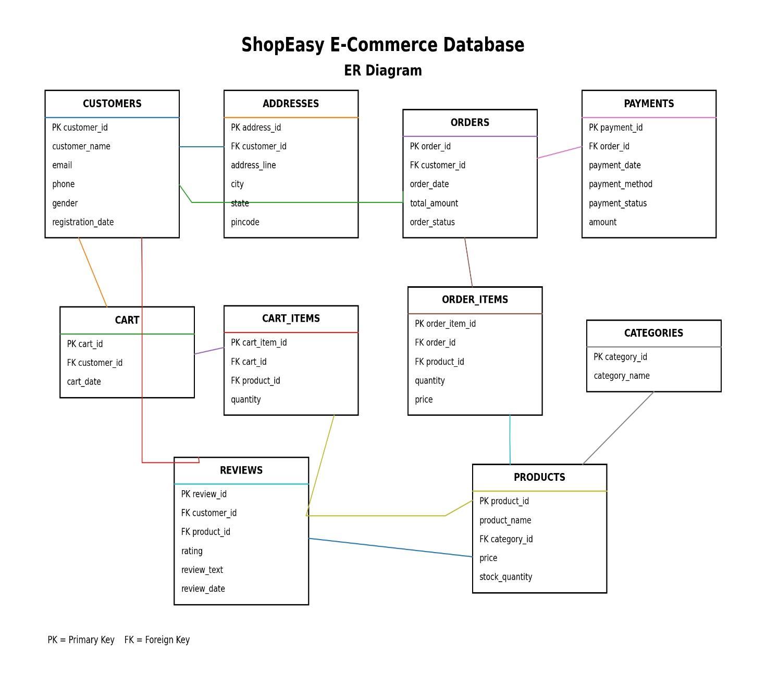

10. SQL Concepts Used
- CREATE DATABASE and CREATE TABLE
- INSERT, UPDATE and DELETE
- SELECT with WHERE and ORDER BY
- INNER JOIN, LEFT JOIN and RIGHT JOIN
- GROUP BY and HAVING
- COUNT, SUM, AVG, MIN and MAX
- Subqueries
- Views
- Window Functions
- RANK () and ROW_NUMBER ()
- LAG () and LEAD ()
- Stored Procedures
- DELIMITER

11. Sample Analytical Queries

1. Find all available products
SELECT *
FROM products
WHERE stock_quantity > 0;

2. Find customers and their orders
SELECT
c.customer_name,
o.order_id,
o.total_amount
FROM customers c
INNER JOIN orders o
ON c.customer_id = o.customer_id;

3. Find total sales
SELECT SUM (total_amount) AS total_sales
FROM orders;

4. Find average order amount
SELECT AVG (total_amount) AS average_order
FROM orders;

5. Find the most expensive product
SELECT *
FROM products
ORDER BY price DESC
LIMIT 1;

12. Project Objectives
- To create a simple e-commerce database.
- To store customer and product information.
- To manage carts, orders and payments.
- To connect different tables using relationships.
- To analyze e-commerce data using SQL.

13. Future Enhancements
- Add online delivery tracking.
- Add discount and coupon management.
- Create a sales dashboard using Power BI.
- Add product recommendation features.
- Add sales prediction in the future.

14. Conclusion
- The E-Commerce Database Management System provides an organized way to manage online shopping data.
- It stores customer, product, cart, order and payment information.
- Relationships between tables help maintain accurate data.
- SQL queries help analyze sales and customer information.
- The project provides practical knowledge of database management and SQL.

15. Scenario-Based Questions and SQL Queries
- Basic Level

- What are all the products that are currently available in stock?

SELECT * FROM products
WHERE stock_quantity > 0
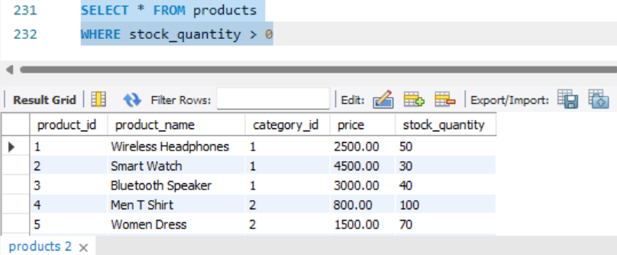
2. Which products have a price greater than ₹5,000?

SELECT * FROM products
WHERE price > 5000

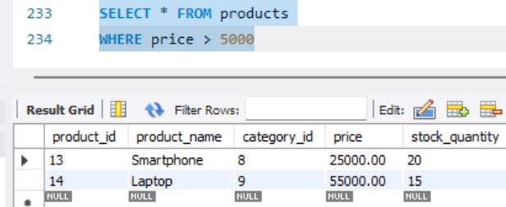

3.Which products have a price between ₹1,000 and ₹5,000?
SELECT * FROM products
WHERE price BETWEEN 1000 AND 5000

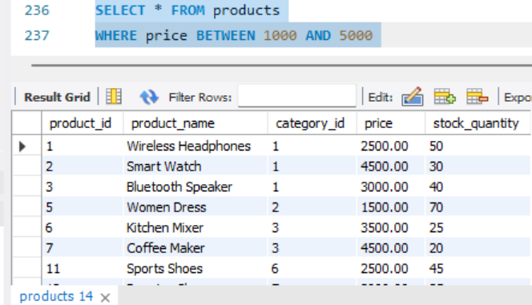

4. Display all products from the highest price to the lowest price.

SELECT * FROM products
ORDER BY price DESC

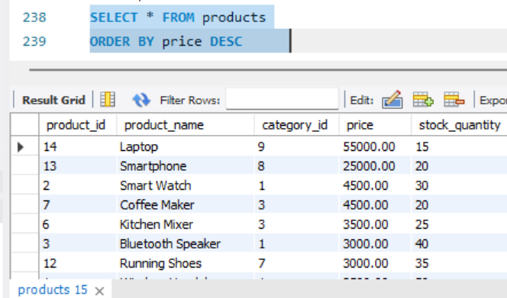

5. Show the 5 most expensive products.
SELECT * FROM products
ORDER BY price DESC
LIMIT 5

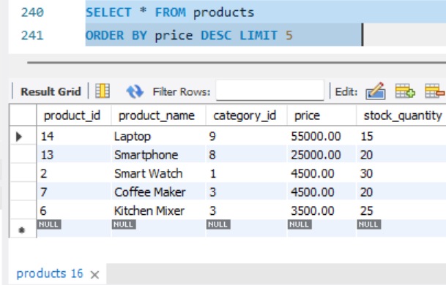

6. Find the products whose name contains the word "Book".
SELECT *
FROM products
WHERE product_name LIKE '%Book%'

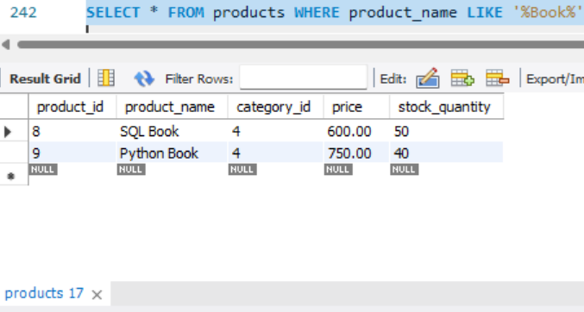

7. How many customers are registered in the ShopEasy system?

SELECT COUNT(*) AS total_customers
FROM customers

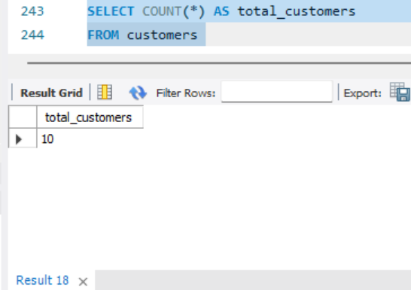

8. How many products are available in the ShopEasy system?

SELECT COUNT(*) AS total_products FROM products

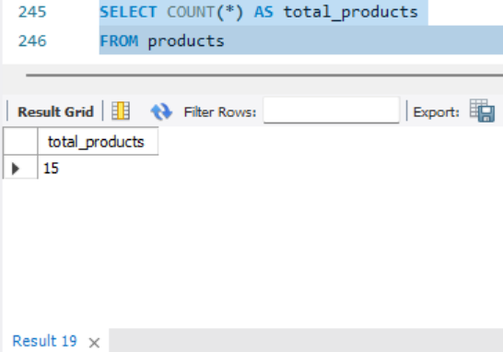

9. What is the total sales amount from all orders?

SELECT SUM(total_amount) AS total_sales
FROM orders

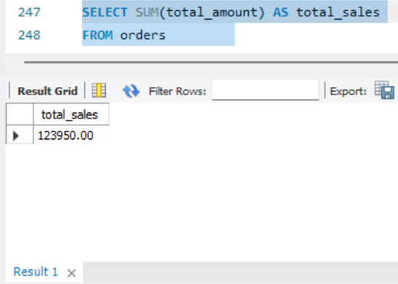

10. What is the average order amount?

SELECT AVG(total_amount) AS average_order FROM orders

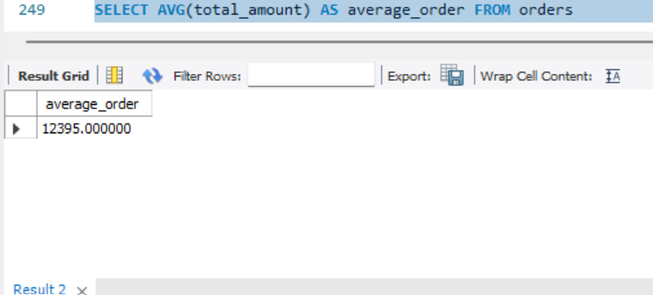

- Intermediate

11. What is the highest-priced product in the ShopEasy store?

SELECT MAX(price) AS highest_price FROM products

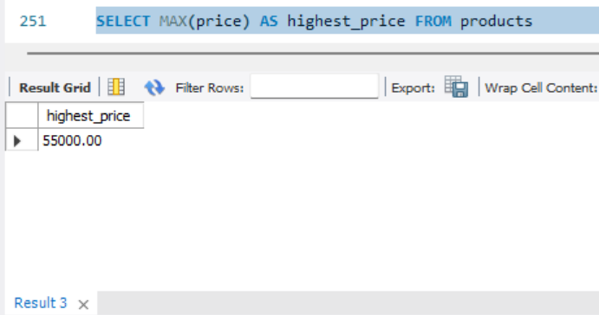

12. What is the lowest-priced product in the ShopEasy store?

SELECT MIN(price) AS lowest_price FROM products

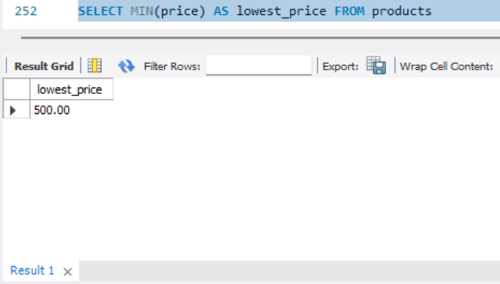

13. How many orders have been placed by customers?

SELECT COUNT(*) AS total_orders FROM orders

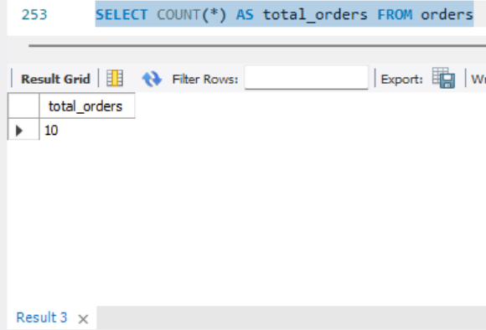

14. Find the total amount of all orders placed by each customer.

SELECT customer_id, SUM(total_amount) AS total_spent
FROM orders GROUP BY customer_id

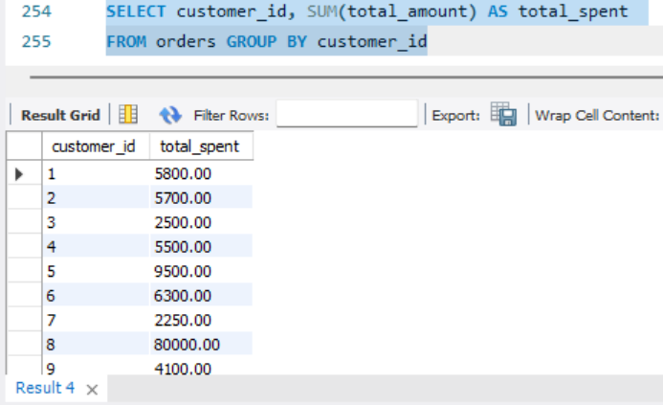

15. How many orders has each customer placed?

SELECT customer_id, COUNT(*) AS total_orders
FROM orders GROUP BY customer_id

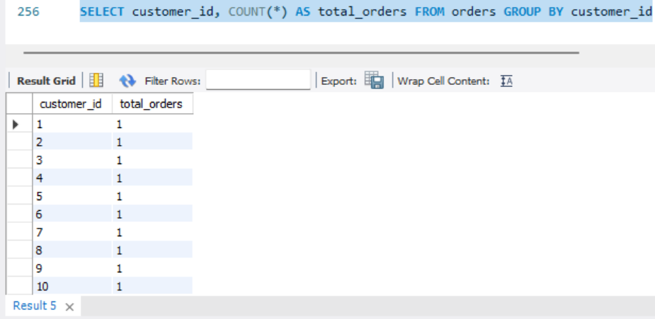

16. What is the average order amount for each customer?

SELECT customer_id, AVG(total_amount) AS average_order_amount FROM orders GROUP BY customer_id

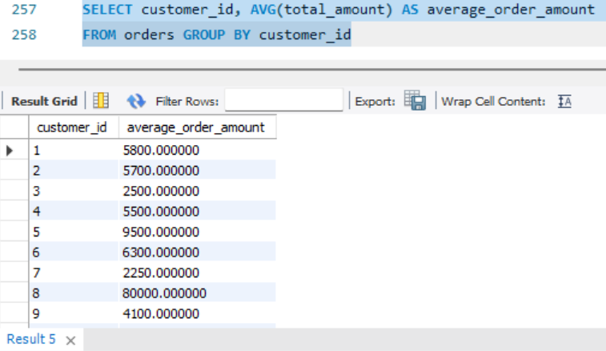

17. Which customers have placed more than one order?

SELECT customer_id, COUNT(*) AS total_orders
FROM orders GROUP BY customer_id HAVING COUNT(*) > 1

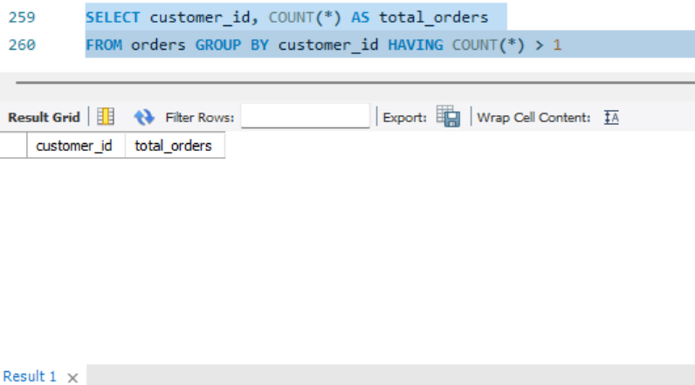

18. Show the customers who have placed orders along with their order details.

SELECT customers.customer_name, orders.order_id, orders.total_amount FROM customers INNER JOIN orders ON
customers.customer_id = orders.customer_id

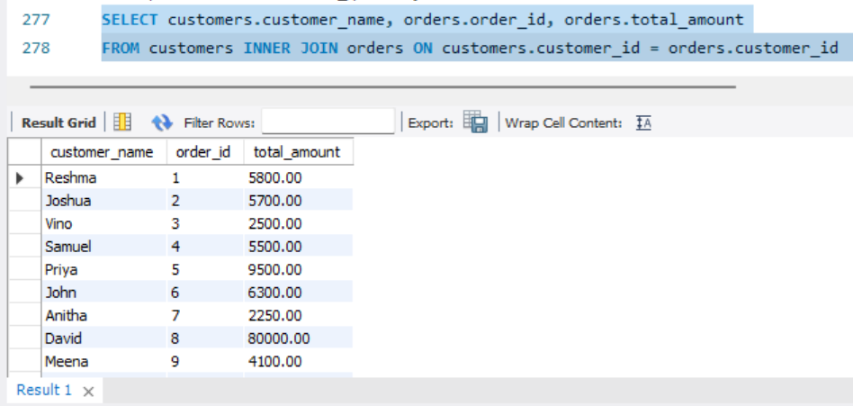

19. Show all customers and their orders, including customers who have not placed any orders.

SELECT customers.customer_name, orders.order_id, orders.total_amount FROM customers LEFT JOIN orders ON customers.customer_id = orders.customer_id

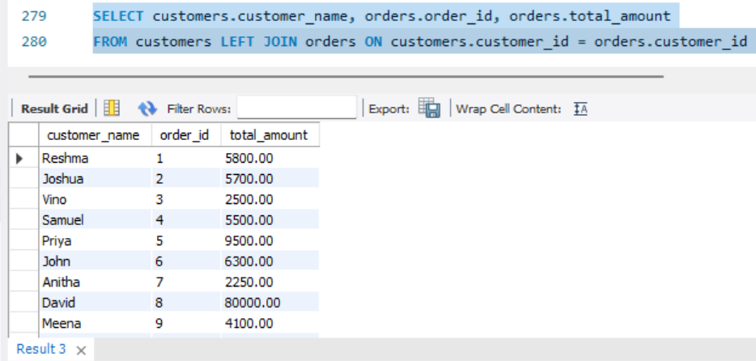

20. Show all products and their order item details, including products that have not been ordered.

SELECT order_items.order_id,products.product_name, order_items.quantity FROM order_items RIGHT JOIN products ON
order_items.product_id = products.product_id

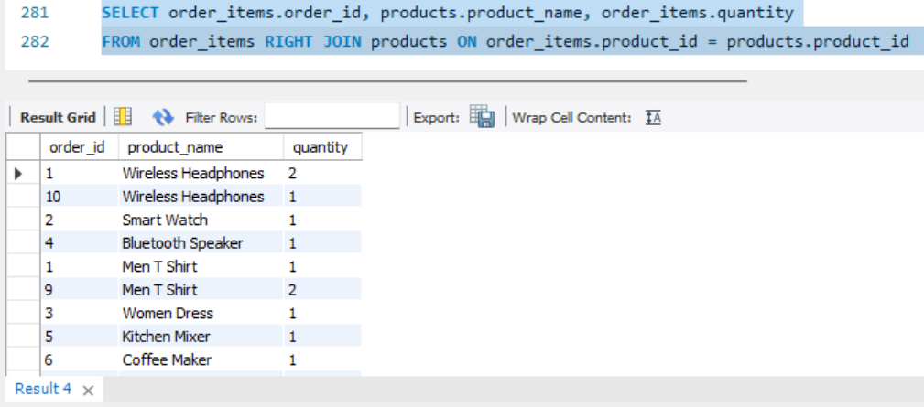

21. Show each product along with its category name.

SELECT products.product_name, categories.category_name, products.price FROM products INNER JOIN categories ON
products.category_id = categories.category_id

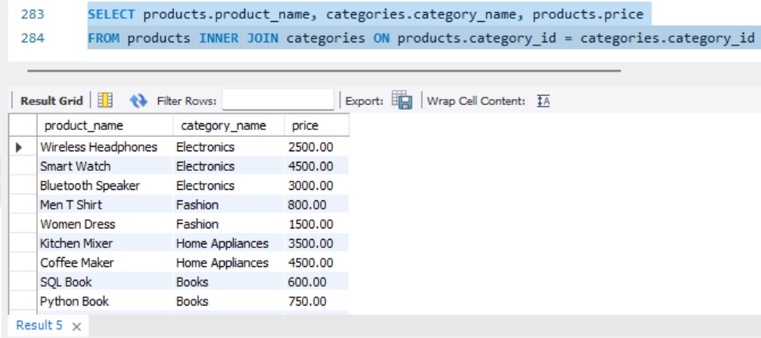

22. Show each order along with its payment details.

SELECT orders.order_id, orders.total_amount, payments.payment_method, payments.payment_status FROM orders INNER JOIN payments ON orders.order_id = payments.order_id

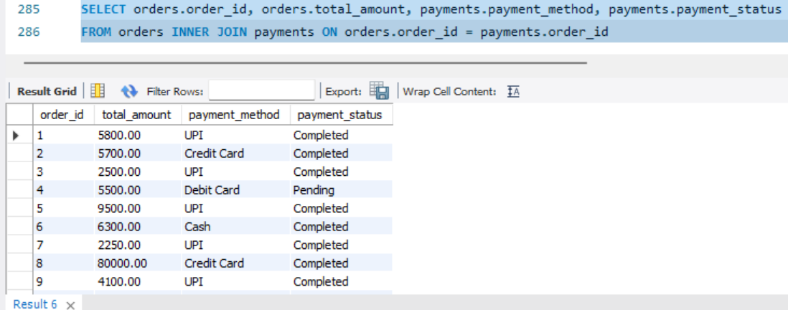

23. Show each customer along with their order and payment details.

SELECT customers.customer_name, orders.order_id, orders.total_amount, payments.payment_method
FROM customers INNER JOIN orders ON
customers.customer_id = orders.customer_id
INNER JOIN payments ON orders.order_id = payments.order_id

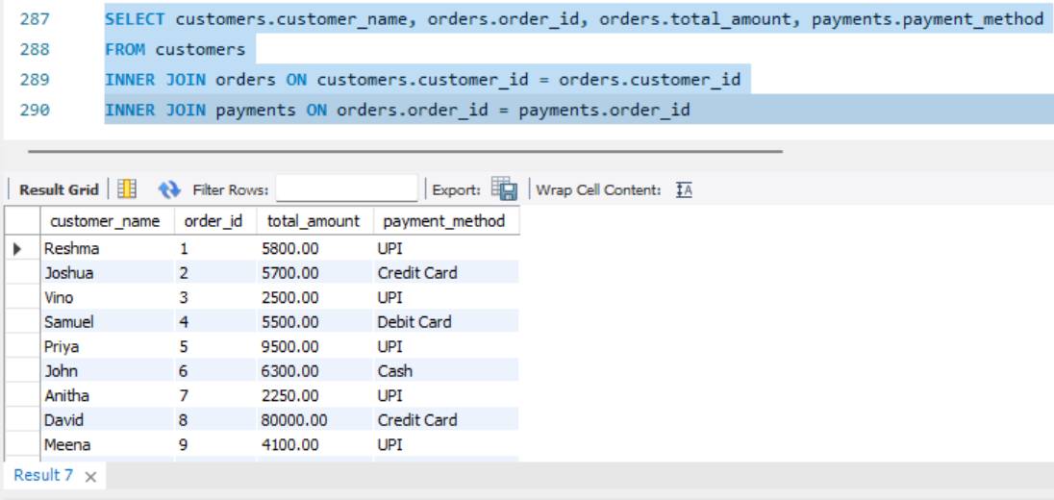

24. Show each customer and the product IDs they ordered.

SELECT customers.customer_name, orders.order_id, order_items.product_id FROM customers INNER JOIN orders ON customers.customer_id = orders.customer_id INNER JOIN order_items ON orders.order_id = order_items.order_id

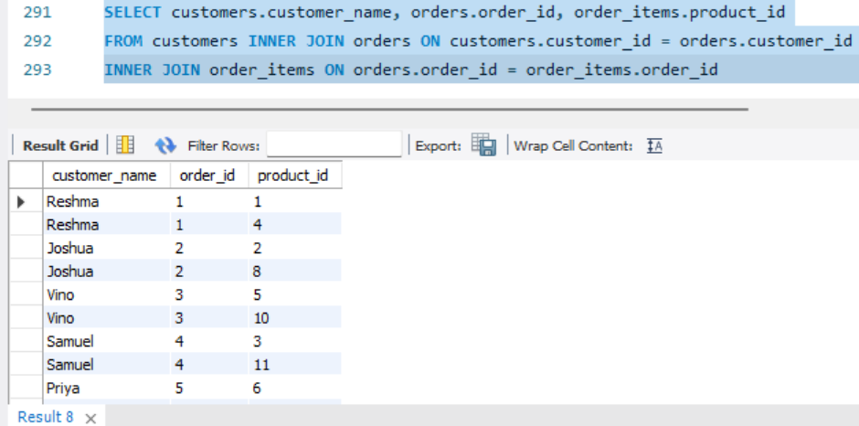
25. Find the total amount spent by each customer.

SELECT customers.customer_name, SUM(orders.total_amount) AS total_spent FROM customers INNER JOIN orders ON customers.customer_id = orders.customer_id GROUP BY customers.customer_name

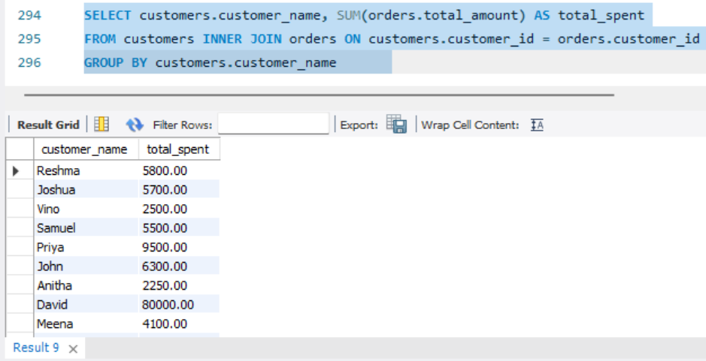

- Advanced

26. Find the products that are priced above the average product price.
SELECT product_name, price FROM products WHERE price > (SELECT AVG(price) FROM products)

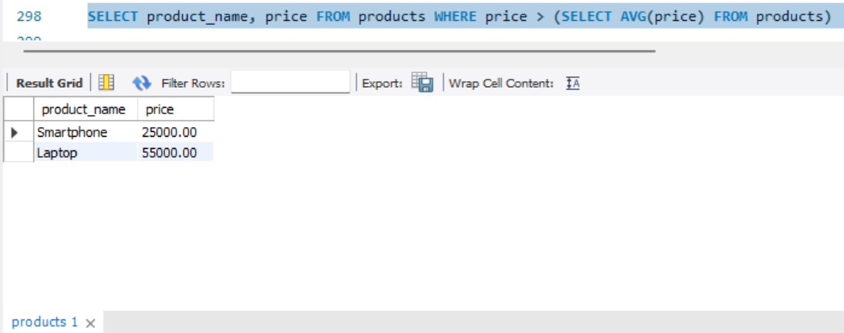

27. Rank the products based on their price from highest to lowest.

SELECT product_name, price, RANK() OVER(ORDER BY price DESC) AS price_rank FROM products

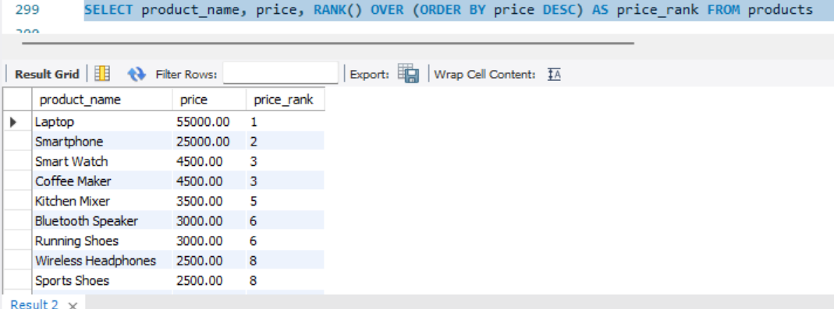

28. Assign a unique row number to each product based on price from highest to lowest.

SELECT product_name, price, ROW_NUMBER() OVER
(ORDER BY price DESC) AS row_number FROM products

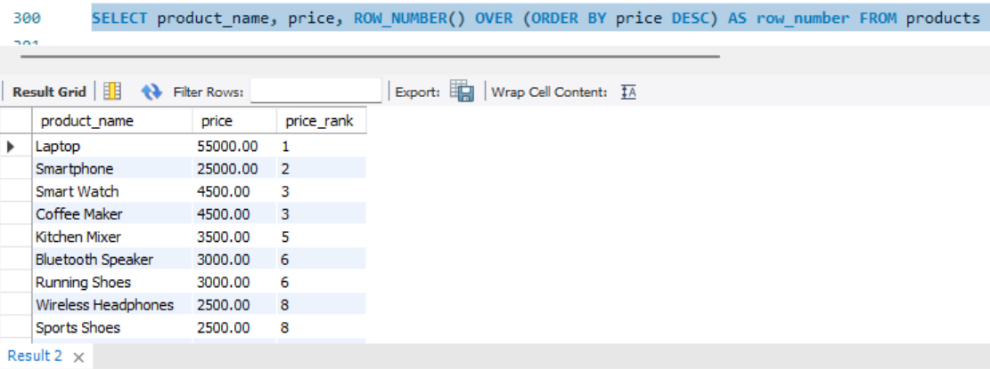

29. Compare each order amount with the previous and next order amount.

SELECT order_id, total_amount, LAG(total_amount) OVER (ORDER BY order_id) AS previous_amount, LEAD(total_amount) OVER (ORDER BY order_id)
AS next_amount FROM orders

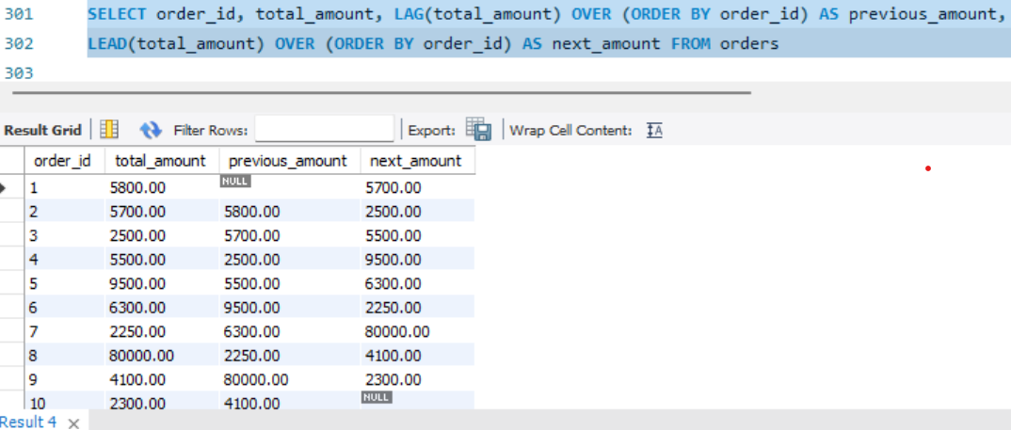

30. Create a stored procedure to display all products.

DELIMITER //

CREATE PROCEDURE show_products()
BEGIN
SELECT * FROM products;
END //

DELIMITER ;

CALL show_products()

